Understanding Heritage of Telangana
Visit to Gongulur Village

To
Department of Higher Education
Ministry of Human Resource Development

Submitted by

Indian Institute of Technology Hyderabad
Sangareddy, Kandi-502285
Telangana, India
https://www.iith.ac.in/

1st December 2019

Understanding Heritage of Telangana
Visit to Gongulur Village
Date: 1.12.2019 | Time: 09:00AM to 02:00PM
Participants: -- 14 Students

Visit to Tanda at Gongulur village: -

Following are some of the points observed by IITH students at Tanda

- Village nursery
- Paddy Cultivation
- Cotton fields
- Some poultry farm is also seen.
- Solar street lights
- Plantation was made along the side of the kacha road, around 1000 plants with safe guards are planted
- The villagers are tribal people and have inferiority feelings.
- They also speak a different language than telugu.
- Total 180 families living in Tanda
- Most of the houses are constructed without pillars
- Stubble farming is not done here, they soak the leftover of paddy fields and let it form composite for 4-5 days.
- Different type of dressing,

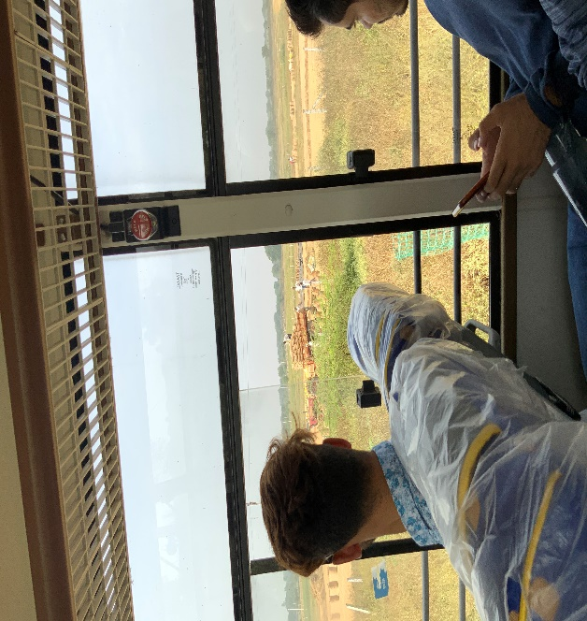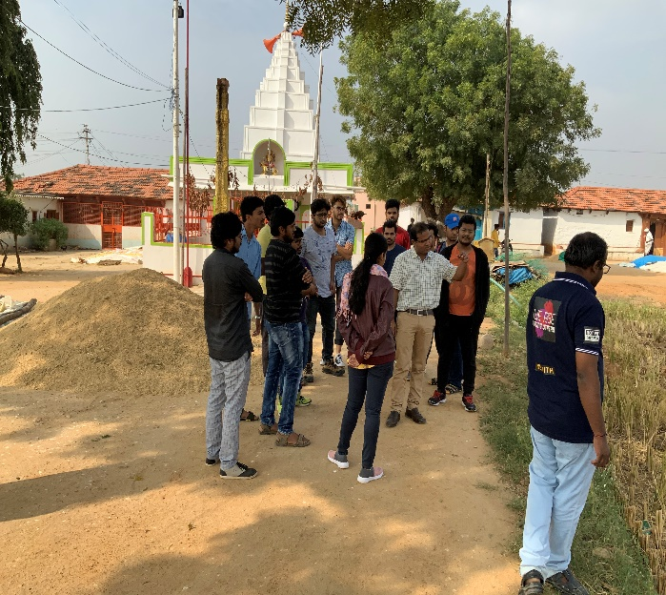
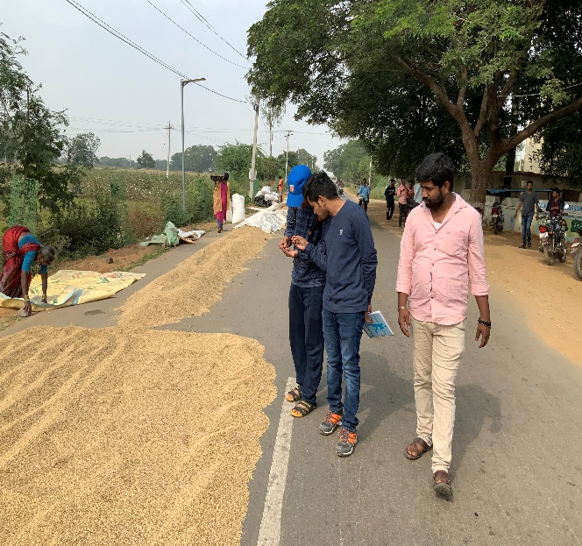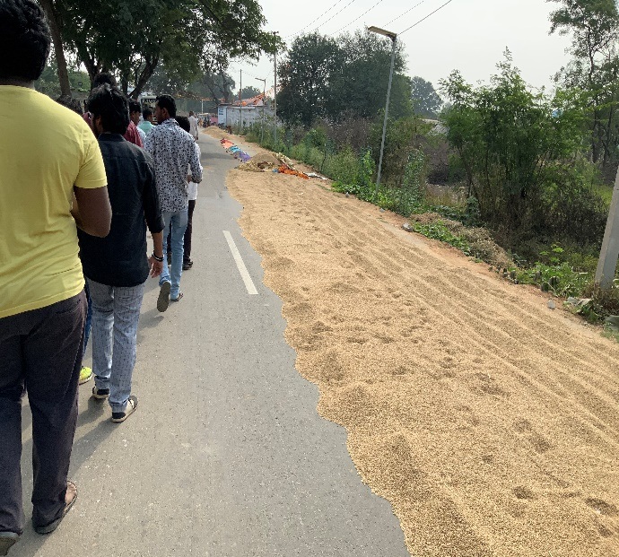
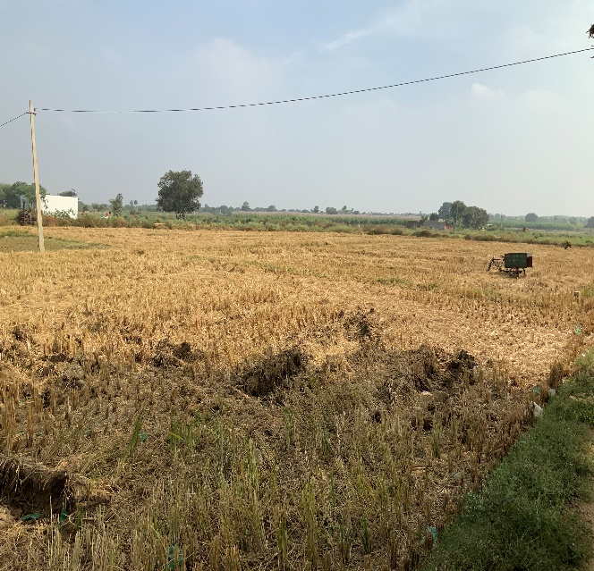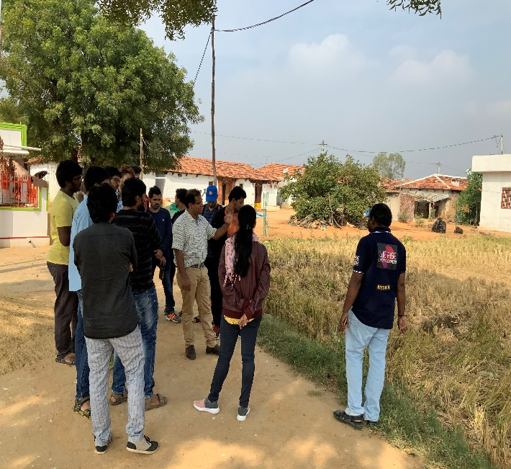

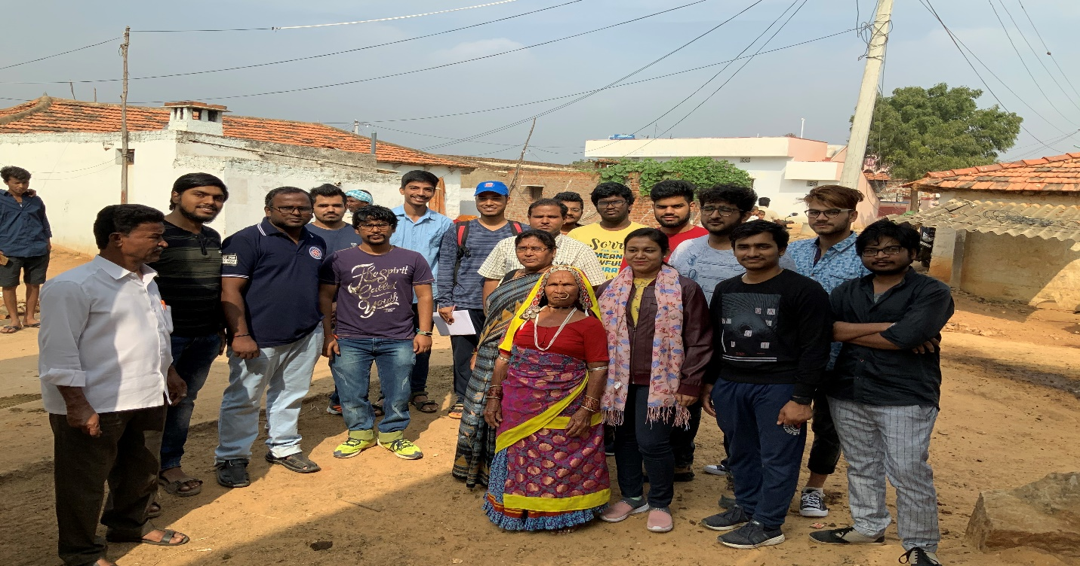

Visit to community hall constructed for Gongulur village people:

Community hall consists of Hall, Kitchen, separate relaxation rooms for men & women. Apart from this a spacious ground to make functions and villagers get together.

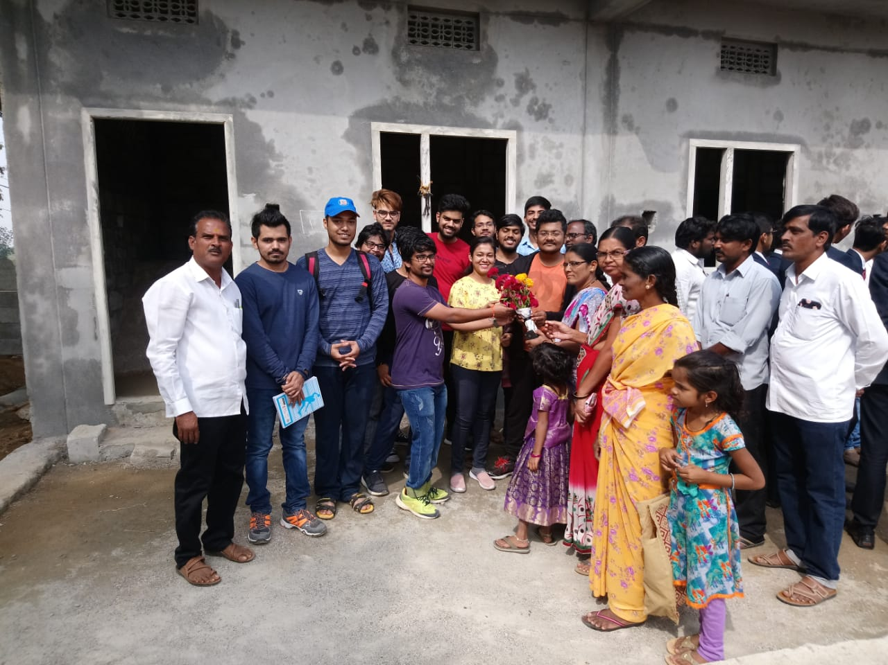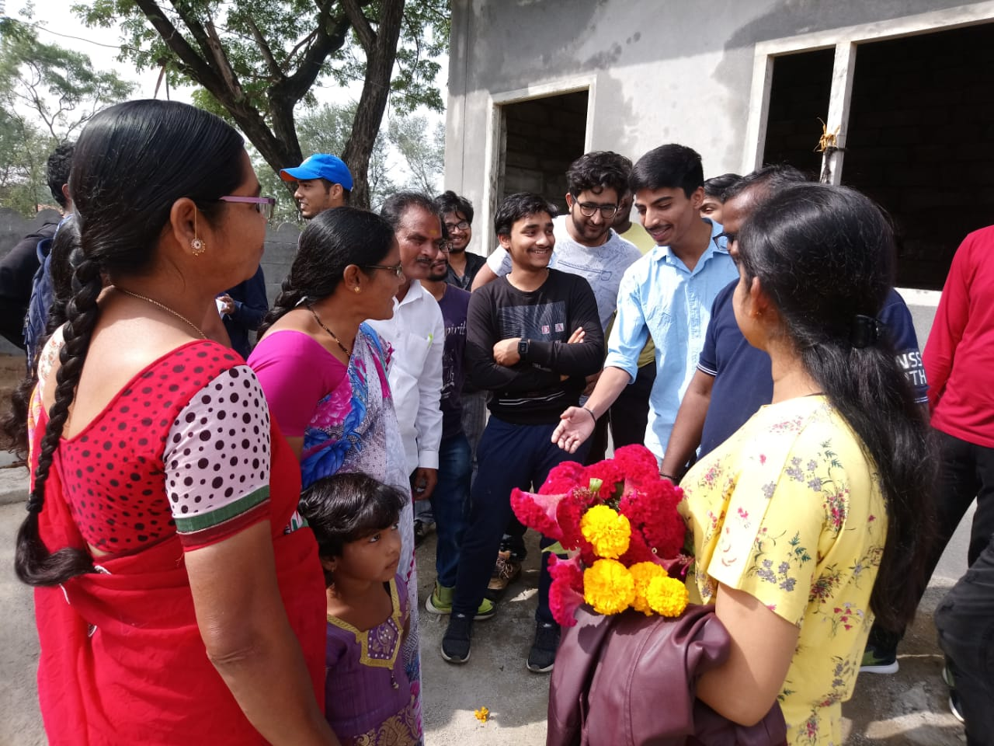

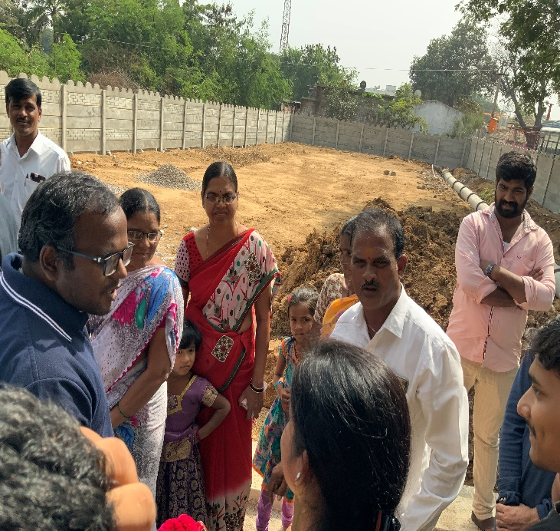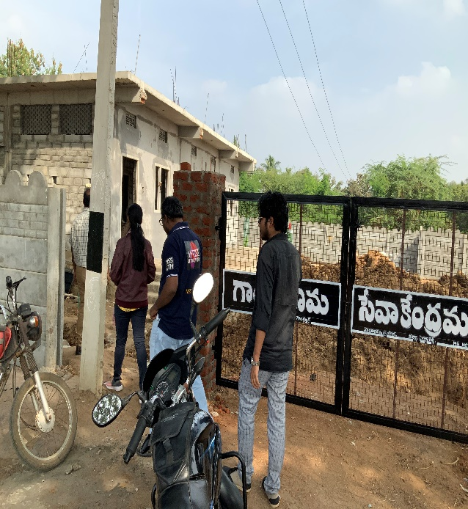

Irrigation System at Gongulur Village: -

Kaleshwaram Lift Irrigation Project:-
https://en.wikipedia.org/wiki/Kaleshwaram_Lift_Irrigation_Project

The village is also going to be benefited by the irrigation project. At present they will get drinking water from singur dam and water for household activities is bore water.

Visit to ZPHS at Gongulur village:

- School Strength is about 320 students
- School Teachers welcomed IIT Students with Banana tree and sugar crane tree
- About 50 students pass class 10th and 12th every year.
- Girl student of this school played in National Level Kabaddi team
- 80% of the pass outs from class 10th don’t think about higher education and join some kind of field work.
- They need to be trained in skills for jobs.

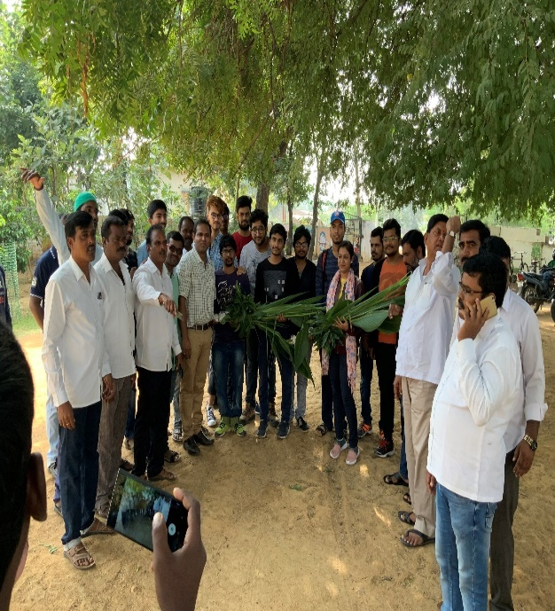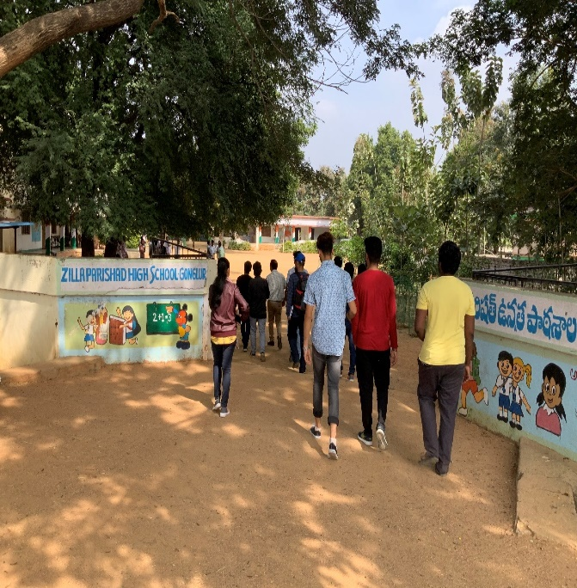

Some Ideas arose by IITH Students: -

- Courage to speak in public: Help students in this area.
- Some NGOs are already cataloguing the Rural Knowledge in the domain of plant medicines.
- Idea of student not being asked for cleanliness of the class and all is a bad policy and we should write a letter to chief minister and chief secretary. First we should also lookup the other side why such a policy was implemented. How do Japanese implement it?
- What government doing to villages
- Form a curriculum of what to teach and how to teach.

- Teach Programming concepts
- Teach English and discuss and conversation in English.
- Teaching the concepts of computer
- Explore of IITH to ZPHS students
- Visiting to ZPHS Gongulur frequently
- Motivation lectures to be given to girl students
- Teaching moral science to students
- Explanation of small small projects to students
- Technology awareness camp for youth in village

